Step 6: Plan Your Evaluation
Tool: Training Outcome Evaluation Planning Template
Instructions:
This step will help you to develop your training outcome evaluation plan. The Training Outcome Evaluation Planning Template offers a series of questions that will bring together the different components of the TEFT. Walk through each of the questions and exercises on the template. When you’ve completed all the sections, you should have a clear picture of the training outcomes you are planning to evaluate and how you will go about the evaluation process. The completed template may be useful as you discuss your intended evaluation with funders and other stakeholders.
On the following pages, you will find two copies of the Training Evaluation Planning Template.
- The first is a copy of the Template to use on your own.
- The second, a sample, begins on page 8 and shows a completed Training Evaluation Planning Template for the case study “Amanga,” available on the TEFT website. The case study describes an evaluation of a national ART training for multiple cadres of health care workers, with a focus on changes in the national guidelines regarding first-line ART regimens. (For this sample, you may find it useful to download a copy of the full case study.)

Training Outcome Evaluation Planning Template

Title of evaluation:

Date of evaluation plan:

TRAINING INTERVENTION OVERVIEW

Background:
Write a brief description that helps set the context for the intervention. Describe the training and its significance and context (including any existing epidemiological and needs assessment data), target population, and time frame.

Training Program Logic Model: [Available on page 17]
If you have completed the Training Evaluation Framework Template (Step 1), you may want to refer to your answers now. The relationship between the Training Evaluation Framework Template and a traditional logic model is that the colored arrows on the TEFT template are an expanded version of the outcomes and impact columns on the logic model. If you prefer, you may also complete the Logic Model Table, made available at the conclusion of this template.

Evaluation OVERVIEW

Rationale/significance of this evaluation:
Describe the reason for conducting the evaluation, and the intended use for the information gained in the evaluation.

Outcome evaluation questions to be answered:
If you have completed the Questions and Indicators Template (Step 4), you may want to refer to your answers now. If not, take a moment to write down the specific evaluation questions that your evaluation seeks to answer.

Process evaluation questions to answer:
If you have completed the Situational Factors Worksheet (Step 2), review the “What you can do” column for items that you will track during the evaluation process.

Evaluation methods:
Please list the indicators you will be tracking, and who the subjects of your evaluation will be, including sample size. Describe the methods you will use to collect data for the indicators that you chose. You may want to refer to the Question and Indicators Template, as well as the example tables in the Design and Methods Example Tables (Step 5).

Evaluation design:
Describe the design of your evaluation: Is this an experimental design (with a randomized control group), a quasi-experimental design (with a non-randomized comparison group), or a non-experimental design (with no comparison group)? Are you comparing data across multiple time points (pre-post)? You may want to refer to the Design and Methods Example Tables.

M&E plan table: [Available on page 18]
This table, which is divided into two sections, will help you pull together a number of the decisions you have made for your evaluation plan, including the outcomes you have chosen to evaluate, the indicators you will use to evaluate those outcomes, and the data collection methods you will use.
In section 1, complete the first 3 columns using the decisions you have made and the tools you have already completed regarding outcomes, indicators, and data collection methods. Enter each outcome you have chosen to evaluate on its own row. You may need to insert additional rows, depending upon the number of outcomes you will evaluate.
Next, complete the remaining columns in section 1, further detailing your plans for executing the evaluation.
To complete section 2, you may find it useful to review your entries in the Situational Factors Worksheet. Use this information to complete the columns. This will help you monitor the indicators you will evaluate and address factors that may influence the outcome of the training.

Data collection:
In this section, you may want to add more detail on how you will collect the data that you’ve listed in the M&E Plan. In addition to identifying the source(s) of the data and the person(s) responsible for collection, you may want to detail here how they will be trained, the process for tool development and piloting, when data will be collected, and how it will be transferred for management and storage.

Data management and storage:
Here you can describe how the data that you collect will be managed and stored. Consider the ethical and practical issues regarding protection of confidential or sensitive data. It may be necessary to clarify whether paper-based data will be stored in locked cabinets, and if electronic data will be in password-protected files.

Ethical considerations:
Describe any ethical considerations that may require internal review board (IRB) review: Does the evaluation involve human subjects (directly, through records, or through other data or specimens)? Describe any additional review procedures that your project will need to go through. Consider: If data were made public and linked to participants, is it possible that this could cause harm to the individuals?

Analysis and interpretation:
Describe how the data will be analyzed, any software to be used, and who will be involved with analysis and interpretation of data.

Dissemination plan:
Describe the audience for dissemination, which information will be shared with whom, and how and when findings will be shared with stakeholders

Appendices:
List references cited, if any. Include relevant examples of previous studies related to this evaluation. Attach data collection tools and other documents, such as consent forms, which will be used in the evaluation.

Planning Template: Logic Model Table
Inputs | Activities | Outputs | Outcomes |  | Impacts
 |  |  | Shorter term | Longer term

Planning Template: M&E Plan Outline
M&E Plan (Section 1 of 2)
Outcomes | Indicators | Methods | Tools/Data Sources | When/Frequency | Person(s) Responsible

M&E Plan (Section 2 of 2)
Process factors | What will be evaluated | Methods | Tools/Data Sources | When/Frequency | Person(s) Responsible

(Sample) Training Outcome Evaluation Planning Template: Amanga

Title of evaluation:
Outcome Evaluation of in-service training for health care workers on new HIV/ART care guidelines in Amanga

Date of evaluation plan:
30 September 2012

TRAINING INTERVENTION OVERVIEW

Background:
Write a brief description that helps set the context for the intervention. Describe the training and its significance and context (including any existing epidemiological and needs assessment data), target population, and time frame.
The Ministry of Health (MOH) of Amanga revised its national HIV Care and Treatment Guidelines in May 2012. In order to remain in alignment with recent updates from the World Health Organization, it has revised antiretroviral treatment (ART) guidelines, including a change in the first-line regimen of ART medicines. The MOH has determined that the new guidelines must be implemented at all its health facilities, from village health posts and health centers to district and regional hospitals.
The national ART curriculum for health care workers is also being revised to reflect these changes. To quickly prepare the health workforce, the MOH has set a goal of training approximately 3,000 health care workers in the new guidelines within the next 4 months.

Training Program Logic Model:
If you have completed the Training Evaluation Framework Template (Step 1), you may want to refer to your answers now. The relationship between the Training Evaluation Framework Template and a traditional logic model is that the colored arrows on the TEFT template are an expanded version of the outcomes and impact columns on the logic model. If you prefer, you may also complete the whole logic model table, available below.

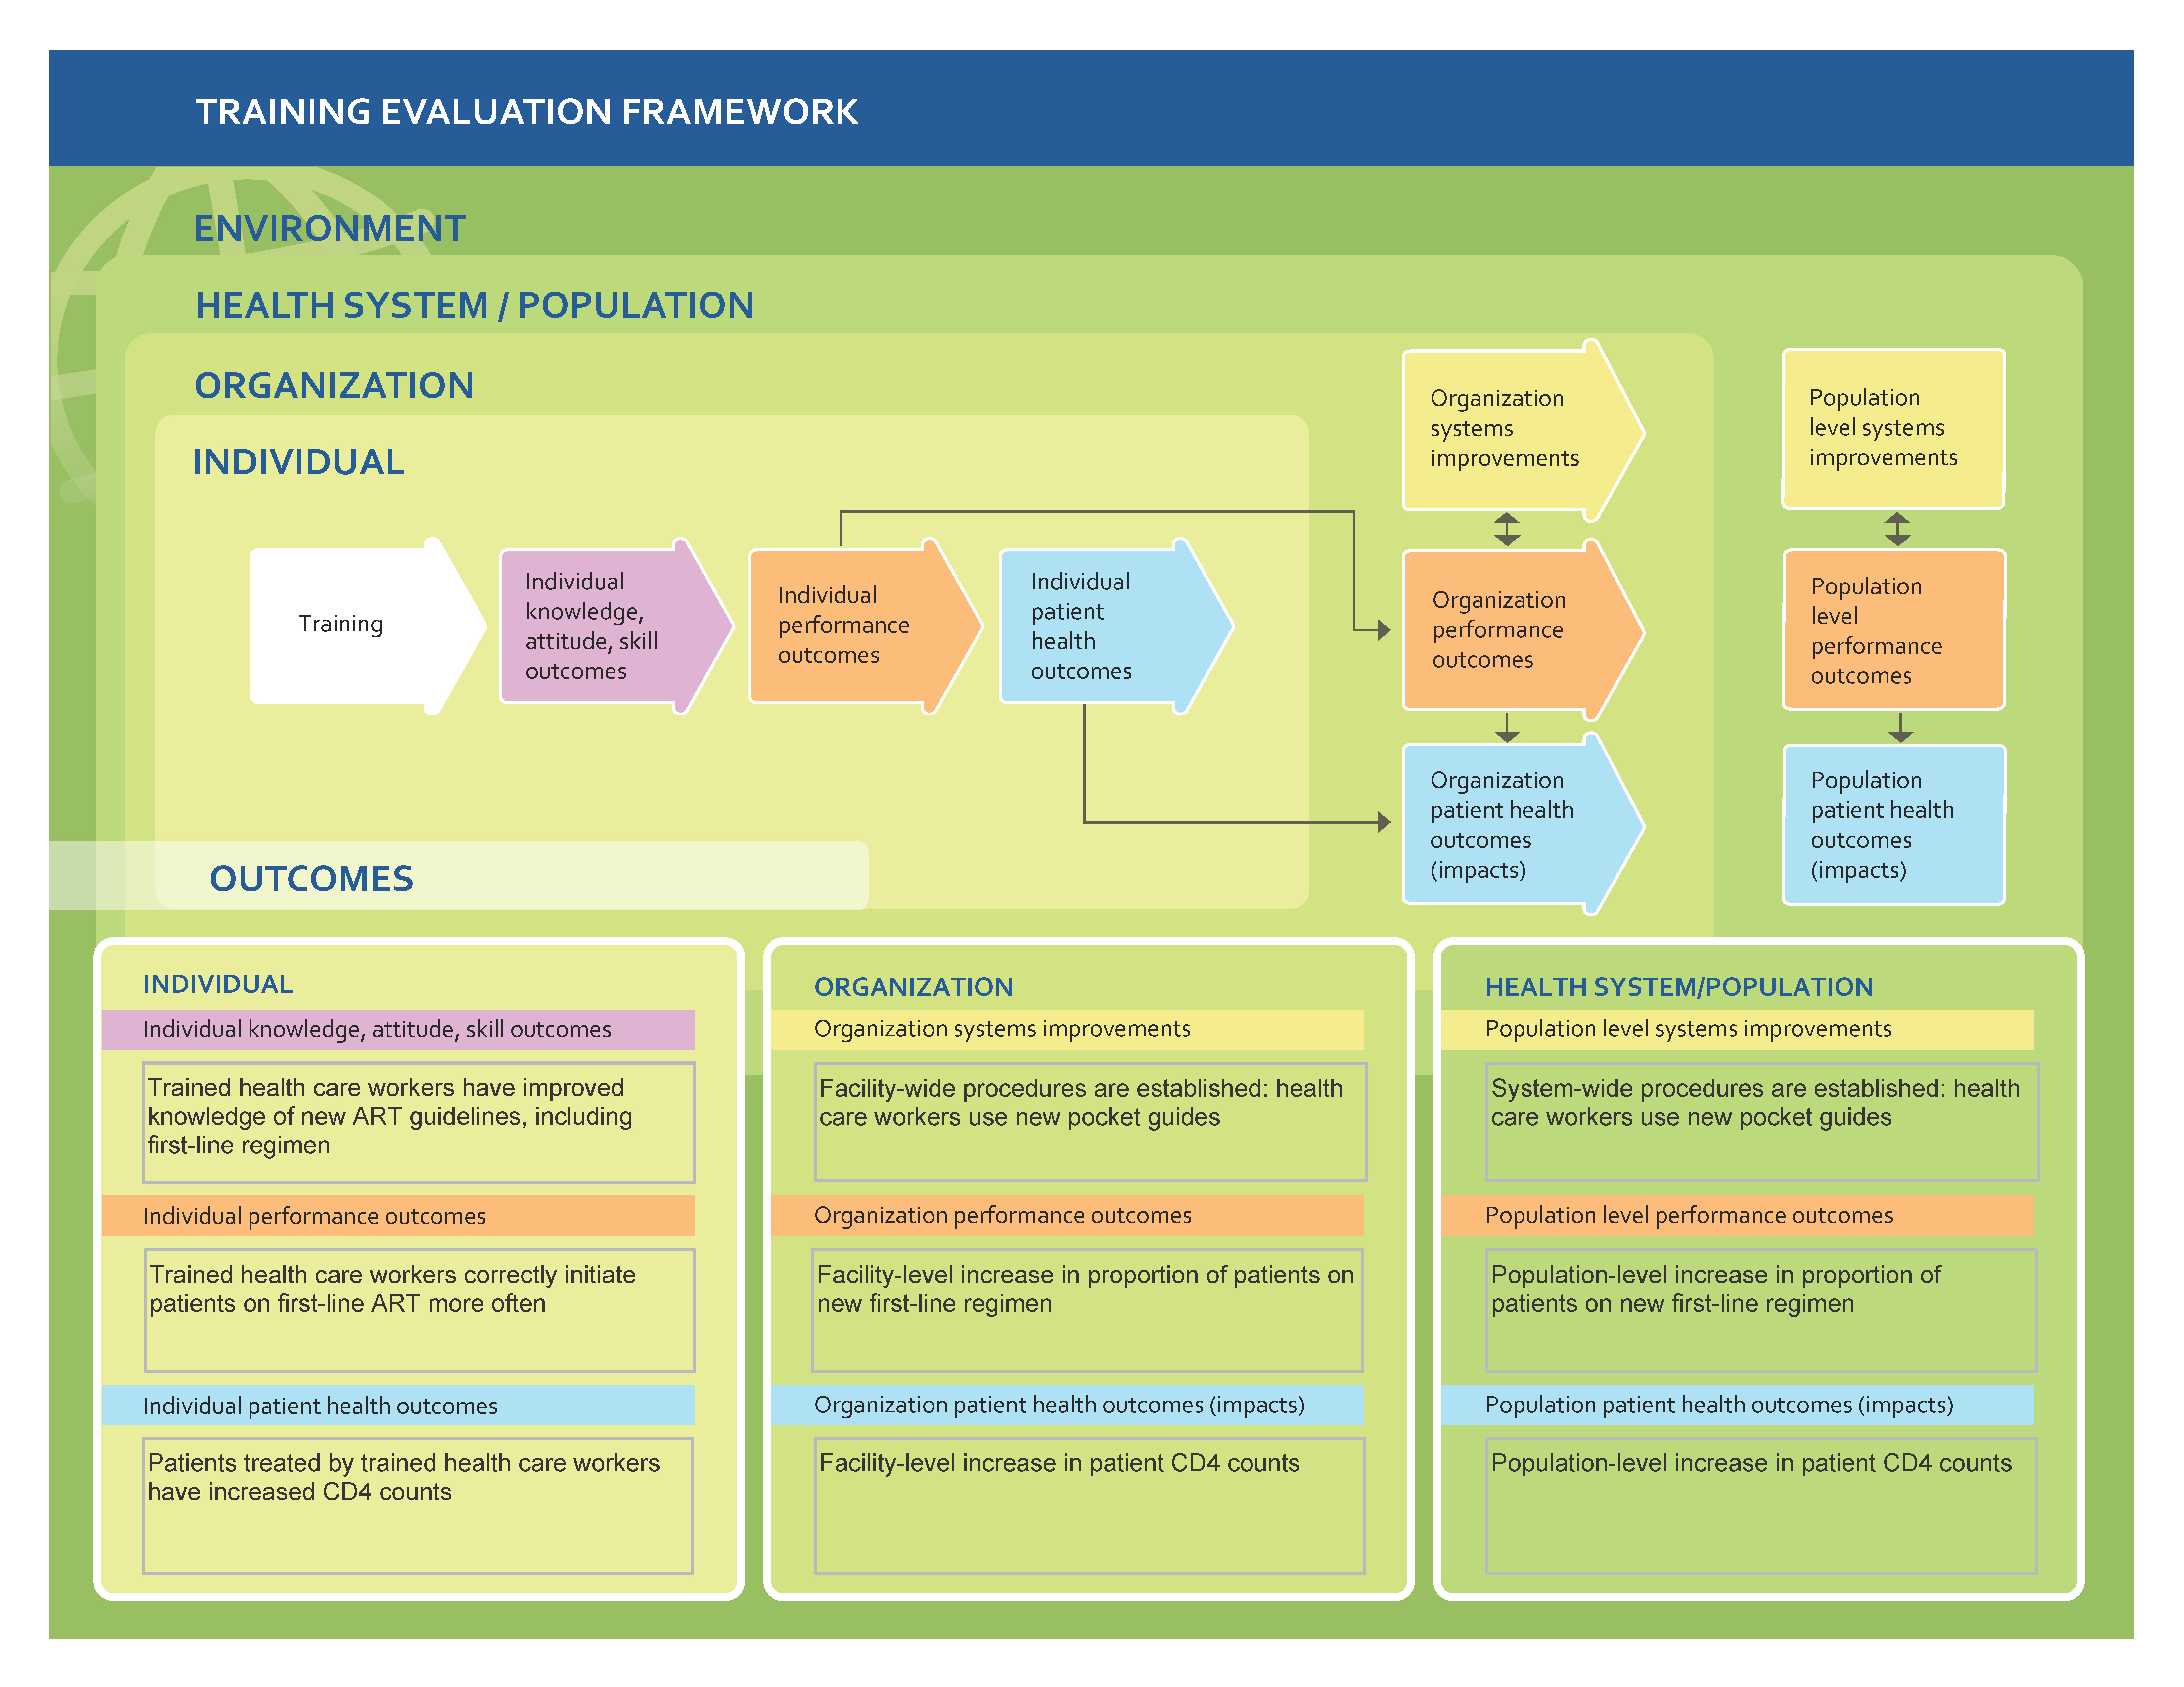
Training Evaluation Framework Template: Amanga

Planning Template: Logic Model Table
Inputs | Activities | Outputs | Outcomes |  | Impacts
 |  |  | Shorter term | Longer term
- Revised curriculum  - Experienced trainers  - Training program expertise  - Funds  - Trainees able to take time off work | Conduct training for 3,000 health care workers on new HIV/ART guidelines including new first-line regimen | 3,000 health care workers trained in new guidelines | - Trained health care workers have improved knowledge of new ART guidelines, including new first-line regimen  - Trained health care workers correctly initiate patients on first-line ART more often  - Patients treated by trained health care workers have increased CD4 counts | - Facility-wide procedures are established: health care workers use new pocket guides  - Facility-level increase in proportion of patients on new first-line regimen  - Facility-level increase in patient CD4 counts | - System-wide procedures are established: health care workers use new pocket guides  - Population-level increase in proportion of patients on new first-line regimen  - Population-level increase in patient CD4 counts

Evaluation OVERVIEW

Rationale/significance of this evaluation:
Describe the reason for conducting the evaluation, and the intended use for the information gained in the evaluation.
The new first-line ART medicines are scheduled to arrive in the country within 2 to 3 months. The MOH has indicated that the training should be rolled out to coincide with the arrival of these medicines and must be completed within a period of 4 months. In technical working group meetings, concerns have been raised about the proposed training format, which is to conduct the training for all cadres together, rather than targeting the content based on the role of the provider. Some members are also concerned that the government’s new policy doesn’t clearly articulate the scope of practice expected for different cadres. Likewise, they worry the policy may not adequately address the varying HIV care and treatment services provided by different types of health care facility, such as health posts and regional hospitals. There are also concerns that if health care workers are not adequately trained, they may provide ineffective counseling on the importance of ART adherence, which could lead to widespread drug resistance, as well as increased morbidity and mortality among patients living with HIV. Thus, there is a significant need to rapidly evaluate the effectiveness of the training on the new ART guidelines to see if the training is effective, and to guide critical decisions regarding next steps for preparing the workforce for the new care practices.

Outcome evaluation questions to be answered:
If you have completed the Questions and Indicators Template (Step 4), you may want to refer to your answers now. If not, take a moment to write down the specific evaluation questions that your evaluation seeks to answer.

Questions and Indicators Template: Amanga
Questions and Indicators Template
General Evaluation Questions | More Specific Evaluation Questions | Very Specific  Evaluation Questions | Anticipated  Outcomes | Outcome  Indicators
Did Amanga’s training on  new national guidelines  result in improvements in health care workers’ knowledge and on‐the‐job performance  in correctly prescribing antiretroviral treatment (ART)? | Did the trained health care workers (“trainees”) show increases in knowledge of the new guidelines on first-line ART regimens? | Did the trainees show improved scores between pre‐ and post‐test knowledge tests on the new guidelines on first‐line ART regimens? | Improved scores on questions related to new guidelines on first-line ART regimens. | % increase in trainees’ post‐training test scores compared with pre-training scores.
 | Did the trained health care workers show improvements in correctly prescribing first-line ART regimens? | Did the trainees show improved on‐the-job performance of prescribing first‐line ART regimens? | Increased proportion of health care workers performing correct prescribing of first-line ART regimens. | % of trainees who are rated on an observation checklist as correctly performing first-line ART prescription at least 80% of the time
 | Were there differences in knowledge and performance based on cadre? | Did some cadres show greater improvement than others in pre‐ and post-tests and in on‐the‐job performance? | Differences among cadres in % improvement on pre‐ and post‐test and observation scores. | Differences among health care worker cadres in % improvements on pre‐ and post‐test and observation scores related to prescribing first‐line ART.

Process evaluation questions to answer:
If you have completed the Situational Factors Worksheet (Step 2), review the “What you can do” column for items that you will track during the evaluation process.
What management support is there at the facilities to support or inhibit trainees in performing their newly learned skills on the job?
Are there any issues related to availability of the necessary drugs, supplies, or infrastructure that might impact the trainees in performing their newly-learned skills on the job?
What is the motivation that trainees have to perform their newly learned skills on the job?

Evaluation methods:
Please list the indicators you will be tracking, and who the subjects of your evaluation will be, including sample size. Describe the methods you will use to collect data for the indicators that you chose. You may want to refer to the Question and Indicators Template, as well as the example tables in the Design and Methods Example Tables (Step 5).
Data on knowledge gained will be evaluated using a written pre- and post-training test. There will also be questions related to motivation: The health care workers’ intention to perform the newly learned skills on the job.
On-the-job performance will be evaluated using a competency checklist completed during expert observations before training and after the training. The observers will also use a checklist to track several factors that may impact performance, including facility patient load, staffing levels, and availability of key medications, supplies, and infrastructure.
Staff at facilities will be interviewed briefly to confirm the information above and to learn about management support for trainees performing their newly learned skills on the job.

Evaluation design:
Describe the design of your evaluation: Is this an experimental design (with a randomized control group), a quasi-experimental design (with a non-randomized comparison group), or a non-experimental design (with no comparison group)? Are you comparing data across multiple time points (pre-post)? You may want to refer to the Design and Methods Example Tables.
The training will be conducted in different facilities over a period of months. Comparisons will be made between trained individuals and facilities that have completed the training first (the “early-training group”), compared with those that have not yet had the training (the “late-training group”). Several pre- and post-training measures for the 2 groups will be compared at 2 different time points: before and after the training is conducted.
- Two groups of individuals and their facilities: “early-training” (those trained in the first 4 weeks) and “late-training” (those trained in the last 4 weeks of the 16-week period).
- Time-points for data collection for both groups: pre-training and post-training
- Data to be collected:
- Individual trainees’ content knowledge related to new ART guidelines (using written test)
- Individual trainees’ performance on key competencies related to new ART guidelines (using observation checklist)
- Facility data: new patients on new first-line regimen (extracted from facility records)
- Process measures to address situational factors (using interviews, observation checklist)

M&E plan:
This table, which is divided into two sections, will help you pull together a number of the decisions you have made for your evaluation plan, including the outcomes you have chosen to evaluate, the indicators you will use to evaluate those outcomes, and the data collection methods you will use.
In section 1, complete the first 3 columns using the decisions you have made and the tools you have already completed regarding outcomes, indicators, and data collection methods. Enter each outcome you have chosen to evaluate on its own row. You may need to insert additional rows, depending upon the number of outcomes you will evaluate.
Next, complete the remaining columns in section 1, further detailing your plans for executing the evaluation.
To complete section 2, you may find it useful to review your entries in the Situational Factors Worksheet. Use this information to complete the columns. This will help you monitor the indicators you will evaluate and address factors that may influence the outcome of the training.

M&E Plan (Section 1 of 2)
Outcomes | Indicators | Methods | Tools/Data Sources | When/  Frequency | Person(s) Responsible
Improved scores on questions related  to new guidelines on first-line ART regimens | % increase between pre- and post-test scores among trained health care workers | Written test of content knowledge | Written test given to trainees | Immediately before training and immediately after training | Alia
Increased % of health care workers performing 80% or more correct on prescribing first-line ART using observation checklist | % of health care workers demonstrating 80% or more  correct in observation checklist  % of newly eligible patients placed on the new regimen | Expert clinicians will observe trainees in patient encounters and score them on competencies related to new guidelines | Observation checklist | Once, before training, and once, within 2 months after training | Alia, Observer
Differences in percentage improvement on pre- and post-test and observation scores among cadres. | Differences among health care worker cadres in % improvement on pre- and post-test and observation scores related to prescribing first-line ART | Expert clinicians will observe trainees in patient encounters and score them on competencies related to new guidelines | Observation checklist | Immediately before training and immediately after training | Alia, Observer

M&E Plan (Section 2 of 2)
Process factors | What will be evaluated | Methods | Tools/Data Sources | When/  Frequency | Person(s) Responsible
Management support for trainees performing new skills | Presence, and nature of management support or lack of support for trainees performing new skills | Interviews with trainees and facility staff | Interview guide | Once, during post-training observation activities | Alia
Heavy workload | Patient load at facility | Interview or survey facility staff | Checklist | Once, during post-training observation activities | Alia, Observer
 | Staffing at facility | Interview or survey facility staff | Checklist | Once, during post-training observation activities | Alia, Observer
Availability of supplies and medications | Availability of new first-line ART | Interview or survey facility staff | Checklist | Once, during post-training observation activities | Alia, Observer
 | Availability of other key supplies and infrastructure | Interview or survey facility staff | Checklist | Once, during post-training observation activities | Alia, Observer
Motivation of trainees to perform new skills on the job | Intention to perform new skills | Questions on pre- and post-training written test | Written test |  | Alia

Data collection:
In this section, you may want to add more detail on how you will collect the data that you’ve listed in the M&E Plan. In addition to identifying the source(s) of the data and the person(s) responsible for collection, you may want to detail here how they will be trained, the process for tool development and piloting, when data will be collected, and how it will be transferred for management and storage.
The Monitoring and Evaluation (M&E) Team will provide oversight to all aspects of the evaluation, including distributing consent forms and collecting the forms from each of the participants before beginning the evaluation. The M&E Team will also orient and train observers and collect the filled forms from them.

Data management and storage:
Here you can describe how the data that you collect will be managed and stored. Consider the ethical and practical issues regarding protection of confidential or sensitive data. It may be necessary to clarify whether paper-based data will be stored in locked cabinets, and if electronic data will be in password-protected files.
Data from all evaluation activities will be entered into Microsoft Excel, and transferred to SPSS v18.0 for analysis. Unique identifiers will be generated to ensure confidentiality for the trainees. These data will be managed in an electronic database with limited, password-protected access. The electronic database will be stored in password-protected data files on a password-protected computer at the OT office. Computer files containing the raw and the cleaned data, with no identifying information, will be kept for 6 years after project completion.

Ethical considerations:
Describe any ethical considerations that may require internal review board (IRB) review: Does the evaluation involve human subjects (directly, through records, or through other data or specimens)? Describe any additional review procedures that your project will need to go through. Consider: If data were made public and linked to participants, is it possible that this could cause harm to the individuals?
Protecting privacy/confidentiality: Confidentiality will be protected through securing computer files and de-identifying all data for analysis. The evaluation team will enter into a written agreement with the holder of the key to the code list which matches individual identities with their unique identification codes. The agreement prohibits the holder of the key to the code list from releasing the key to any member of the evaluation team under any circumstances.
Potential risks and benefits: No potential risks to the trainees whose data will be evaluated are anticipated, as the analysis and dissemination of results will be conducted on de-identified data. However, the unlikely possibility of accidental disclosure of information could result in harm to trainees in the form of negative professional or personal perceptions by others, and consequences of those perceptions. The general public may benefit indirectly from the information obtained through the findings from this evaluation; recommendations regarding the training of health care workers in the new ART guidelines contribute to improved care.

Analysis and interpretation:
Describe how the data will be analyzed, any software to be used, and who will be involved with analysis and interpretation of data.
Multivariate analysis of variance (MANOVA) will be used to describe the outcomes for the 2 groups, across the 2 time points, and any interactions seen with regard to type of facility and cadre.

Dissemination plan:
Describe the audience for dissemination, which information will be shared with whom, and how and when findings will be shared with stakeholders
Upon completion of the evaluation, the findings will be written into a report and first shared with the MOH. In collaboration with the MOH, the report will then be presented in an organized formal gathering to different stakeholders: development partners, donors, and other relevant ministries. The report will also be printed and distributed upon request.

Appendices:
List references cited, if any. Include relevant examples of previous studies related to this evaluation. Attach data collection tools and other documents, such as consent forms, which will be used in the evaluation.
(End Sample)

