Step 3: Evaluation Considerations
Tool: Evaluation Considerations Tool

Instructions: For each of the 5 considerations, use your computer mouse to drag and drop the stars in the “Ratings” column to locations along the arrows that best reflects your program’s circumstances. Make notes using the text boxes in the right-hand column to explain your reasoning for each rating. For detailed instructions, and a completed sample of the tool, see pages 2 – 6.
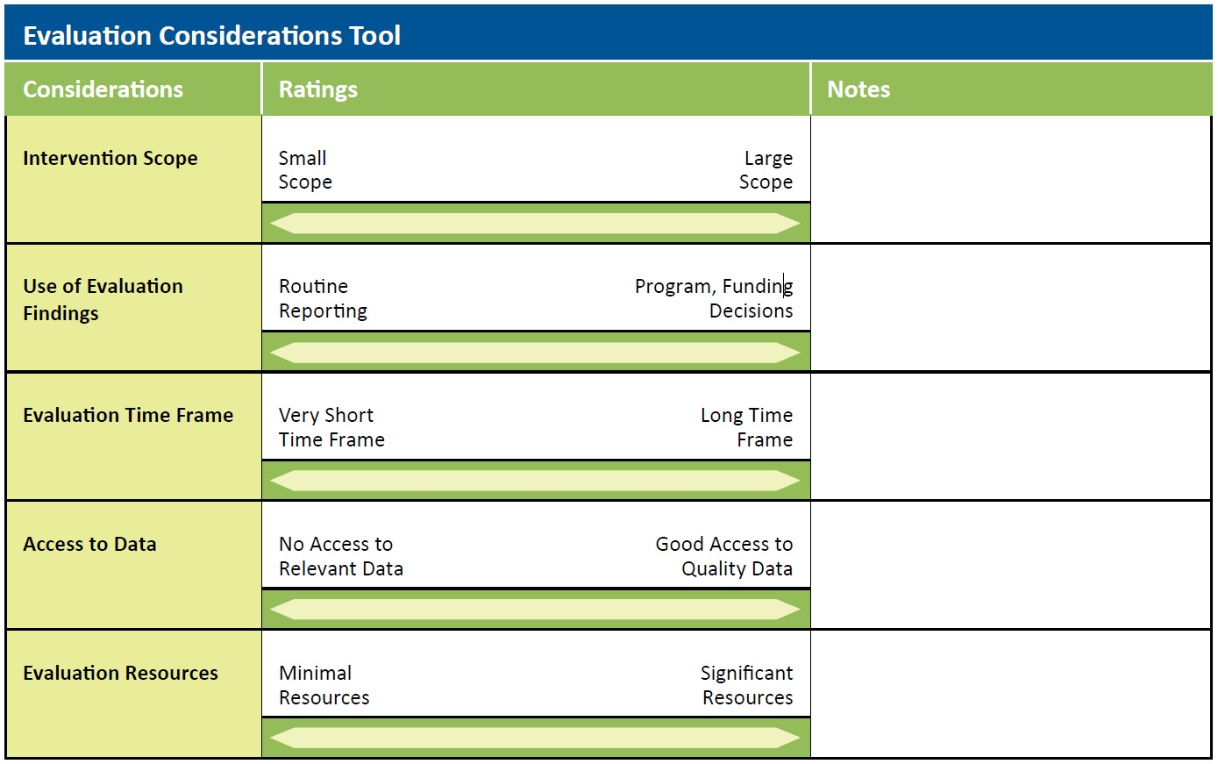

Overview:
Deciding at which outcome level to evaluate your training, what type of outcome to evaluate, and which design and methods to use for data collection is an artful process. While there is no single formula to guide the decision, the Evaluation Considerations Tool can help you structure your thinking. It may be used alone, but is best used after you have completed the Training Evaluation Framework Template.
Instructions for Completing the Evaluation Considerations Tool:
- Review the five considerations: Take a moment to look over the Evaluation Considerations Tool. Notice the five considerations listed in the rows of the tool.
- Rate the considerations for your outcome evaluation: For each consideration, place a check mark at a location along the scale (the line) that best reflects your program’s circumstances. The five considerations are described in further detail below.
- Determine your level of evaluation: If you have completed the Training Evaluation Framework Template, use it to revisit the outcomes your training is intended to achieve. With these in mind, look at the combination of check marks on the Evaluation Considerations Tool, and consider how the check marks might influence your choice of evaluation level and outcomes on the Framework Template.
  - Your ratings on these considerations will also be useful in thinking about your evaluation planning, design, and methods (Steps 5 and 6). Look at the considerations that have been checked farthest to the left on the scale. Will those considerations limit your ability to conduct evaluation activities that fall into the category of health system/population level, or even organization level on the Training Evaluation Framework Template? If so, you may need to opt for an evaluation that focuses on the individual level. If an evaluation at the organization or health system/population level is needed, you may be able to find an evaluation design and/or methods that could address this challenge.
- If you can, review the case studies provided on the TEFT website to help you think about your decisions. In the end, you’ll use both the tools and your professional expertise to select the evaluation level, design, and methods that seem the best fit.
An Introduction to the Five Considerations
- The Scope of the intervention being evaluated: An intervention that is very small in scope, and that has minimal resources invested in it, such as a single training or a one-hour lunchtime training session, will likely have different evaluation needs than a larger intervention, such as a course that is taught annually. These will also differ from an intervention that has a regional or national scope, such as a national curriculum that is taught regularly and throughout a country. You may also need to consider whether the training is innovative or new in some way. For such a training, even if the scope is relatively small, there may be more need for outcome evaluation.
- The Use of the evaluation findings: There are a wide range of uses for evaluation data. Programs will frequently use evaluative data to strengthen or improve the program and to determine learner satisfaction. This kind of process information is valuable and necessary. Outcome evaluation findings may also be used to determine whether the learning objectives of the training have been met. They may also address questions about whether the skills and content trainees learn are truly being transferred to their on-the-job performance. Program managers, funders, and other stakeholders may also use the information to guide decisions regarding future program planning and fund allocation, and—particularly in the case of a new intervention—may seek patient, facility, or population level outcomes to decide whether ongoing funding of a program is warranted.
To determine how feasible it will be to conduct various evaluation activities, you will need to consider several additional issues:
- Time Frame: The time available to conduct an evaluation may be driven by funder requirements for completion of the activities. The time frame often is restricted to one or two years. Another consideration is how urgent the need is to provide evaluative information, from a public health standpoint. For example, an initiative to train a new cadre of health care workers on an essential care task may require immediate evaluative information to decide the risks and benefits of a new model of care, while a program looking at sustained outcomes of an intervention would require a longer time frame for evaluation.
- Access to Data: Different levels of evaluation will require you to collect different types of data. Sometimes, you can answer evaluation questions at the facility/organization, regional, or national levels by using data collected regularly at those levels. Your team will need to consider whether the data being collected are relevant to the training intervention, accessible to the evaluation team, and of high enough quality to draw valid conclusions. If there are no high quality data available, you’ll need to find out whether the evaluation team has, or can obtain, permission to collect data. This has implications for the amount of resources needed for the evaluation.
- Evaluation Resources for conducting evaluation activities: Many programs will wish to evaluate long-term outcomes or impacts of their interventions, but these evaluation activities may be limited by the resources available. In addition, certain evaluation activities will require more time to conduct or require specific technical skills. Programs need to consider these questions:
- What are the staffing requirements for the evaluation?
- Are staff available to conduct the evaluation activities? Are they technically qualified?
Below, you will find an example of a completed Evaluation Considerations Tool
- This provides an example of one way an evaluation planner might fill the tool out. The example here follows the hypothetical case study “Amanga” (available on the TEFT website) which describes an evaluation of a national antiretroviral treatment (ART) training for multiple cadres of health care workers, with a focus on changes in the national guidelines regarding first-line ART regimens.

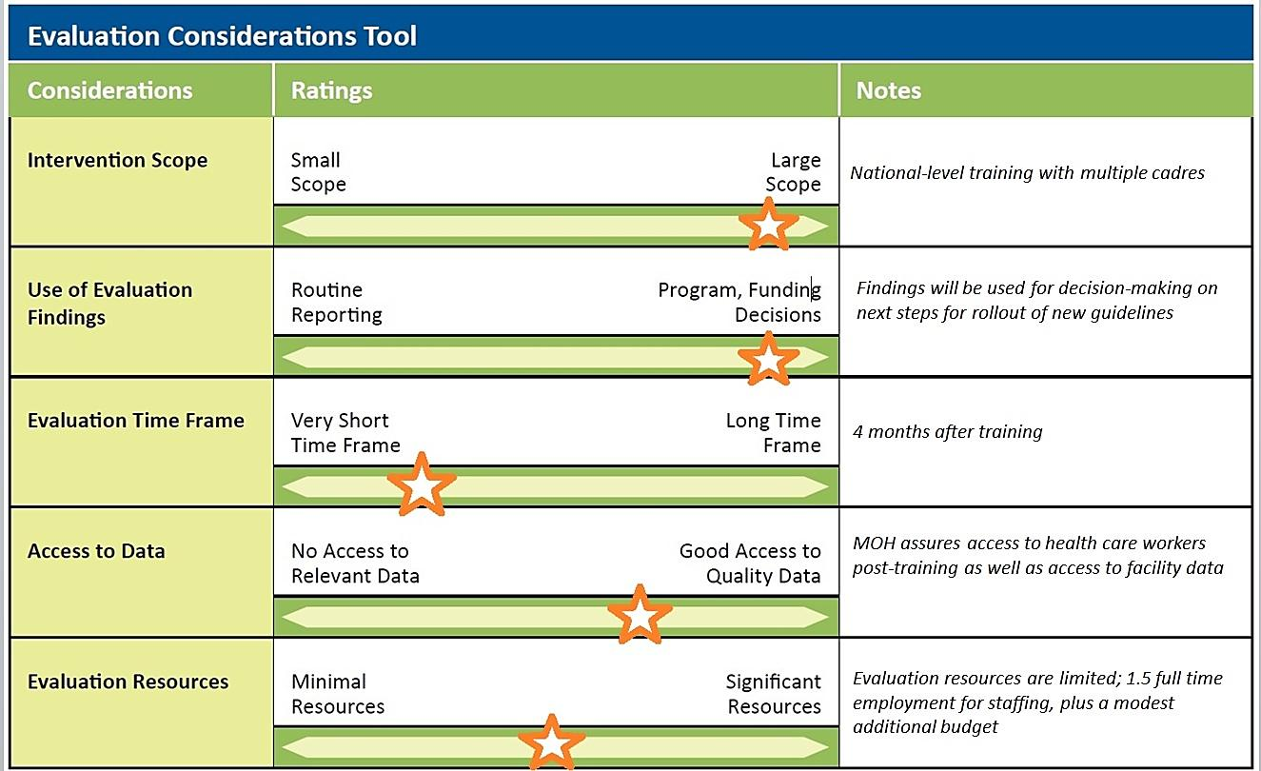
(SAMPLE): Evaluation Considerations Tool

