
Session 6: Clinical Diagnosis and
Decision-Making Skills
Facilitator Guide
Basics of Clinical Mentoring

Session 6: Clinical Diagnosis and Decision-Making Skills

 Time: 1 hour (60 minutes)

Learning Objectives
By the end of this session, participants will be able to:
- Identify concepts of evidence-based medicine
- Identify common errors in clinical reasoning that should be avoided

Session Overview
Step | Time | Method | Title | Resources
1 | 5 minutes | Presentation | Introduction and Learning Objectives (slides 1–2) | LCD or overhead projector
2 | 15  minutes | Presentation | Evidence-Based Medicine (slides 3–8) | LCD or overhead projector  Handout 6.1
3 | 5 minutes | Presentation | Key Points (slide 9) | LCD or overhead projector
4 | 35 minutes | Activity | Case Study (slides 10–17) | LCD or overhead projector  Worksheet 6.2

Resources Needed
- LCD or overhead projector
- Flip chart and markers

 Handouts
- Handout 6.1: Avoiding Errors in Clinical Reasoning

Worksheets
- Worksheet 6.2: Clinical Decision-Making Case Study

Key Points
- Resource-poor settings may lack diagnostic technology that mentors are accustomed to, so clinical reasoning skills are important.
- Nine principles of evidence-based medicine guide the clinician in diagnosis, emphasizing the most common and/or fatal potential causes, and avoiding errors in clinical reasoning.

Training Material

 Trainer instructions: Step 1 (slides 1–2)—5 minutes
Present slides 1–2, Introduction and Learning Objectives, and provide participants an introduction to this session.

Slide 1 | 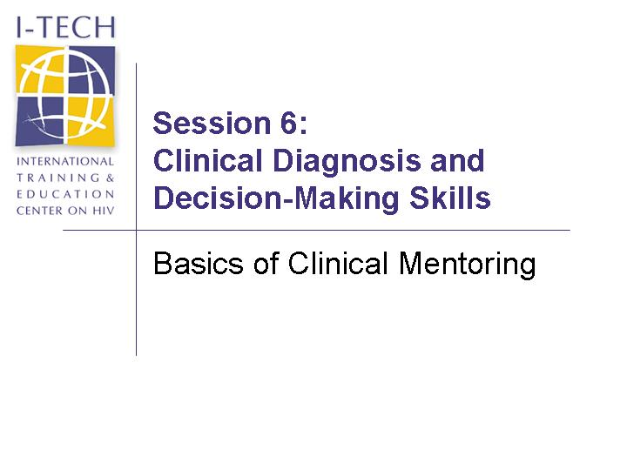
Slide 2 | 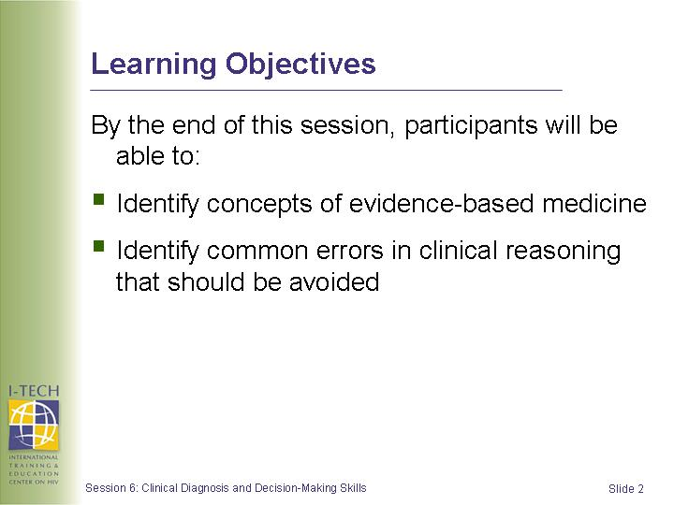

Trainer instructions: Step 2 (slides 3–8)—15 minutes
Present slides 3–8, Evidence-Based Medicine. Refer participants to Handout 6.1 for a list of the principles contained in these slides.

Slide 3 | 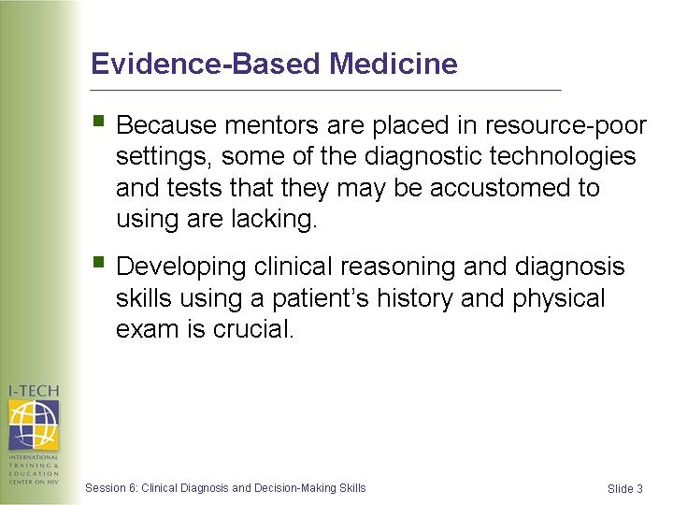 | In addition, these are principles that should be taught to/reviewed with mentees so as to improve their clinical diagnosis skills.
Slide 4 | 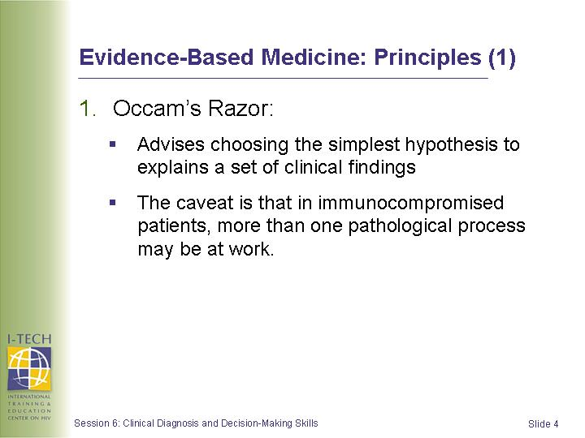 | See Handout 6.1 for a list of the principles contained on this slide and the following slides.
Slide 5 | 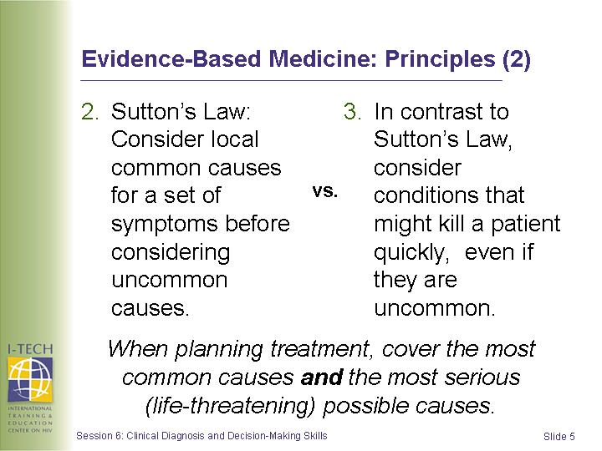
Slide 6 | 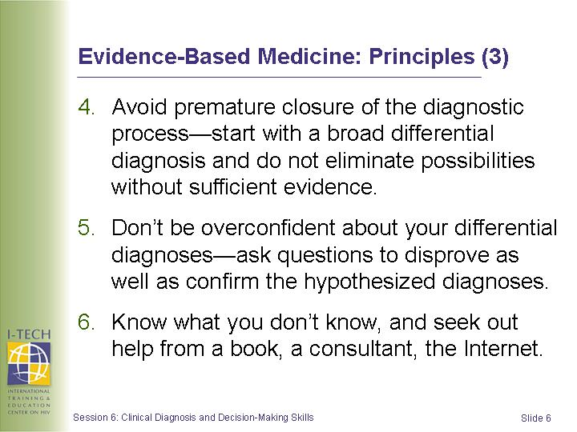
Slide 7 | 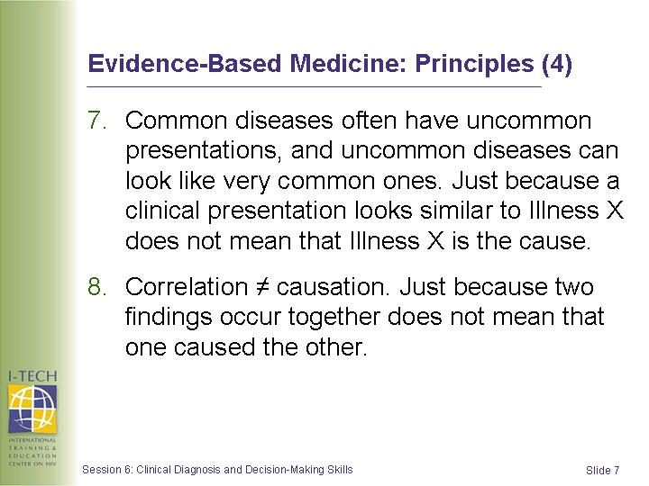
Slide 8 | 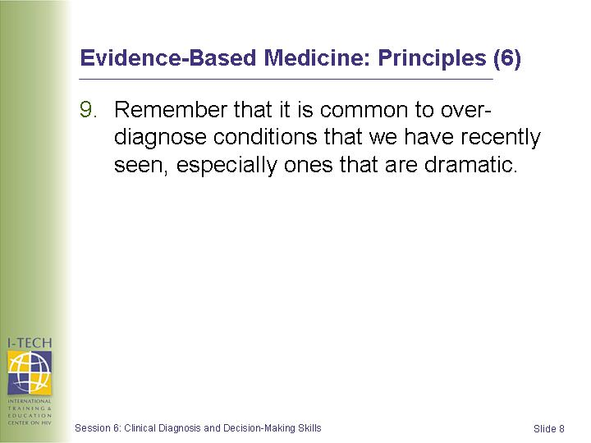

Handout 6.1: Avoiding Errors in Clinical Reasoning

- Occam’s razor advises choosing the simplest hypothesis that explains a set of clinical findings. HOWEVER, keep in mind that when dealing with an immunocompromised patient, there may be more than one pathological process occurring at the same time in the same or in different organs.
- Sutton’s law (named after a famous bank robber who explained that he robbed banks because “that’s where the money is”) suggests that a clinician consider common causes in the local region for a patient’s symptoms before considering uncommon causes.
- Plan your initial empiric or syndromic treatment so that you cover the most common causes and the most serious (life threatening) possible causes.
- In contrast to Sutton’s law, consider what could kill a patient rapidly, even if that diagnosis may be uncommon.
- Avoid premature closure of your diagnostic process. Start out with a broad differential diagnosis and don’t prematurely eliminate possibilities without sufficient evidence.
- Don’t be overconfident. Seek reasons why your decisions may be wrong and consider alternative hypotheses. Ask questions that would disprove as well as prove your current hypothesis.
- Know what you don’t know. Seek the missing information (e.g., from a book, a consultant, from the Internet).
- Common diseases sometimes have uncommon presentations and uncommon diseases can sometimes look like very common ones. Just because a clinical presentation looks similar to or is “representative of” a particular illness does not prove that the cause is due to that illness.
- Remember that we tend to over diagnose conditions that we have recently seen, especially those that were particularly dramatic or in which we made a mistake that we want to avoid in the future.
- Correlation ≠ causation. Just because two findings occur together, doesn’t necessarily mean that one caused the other.

Trainer instructions: Step 3 (slide 9)—5 minutes
Review the Key Points and ask participants if they have any remaining questions.

Slide 9 | 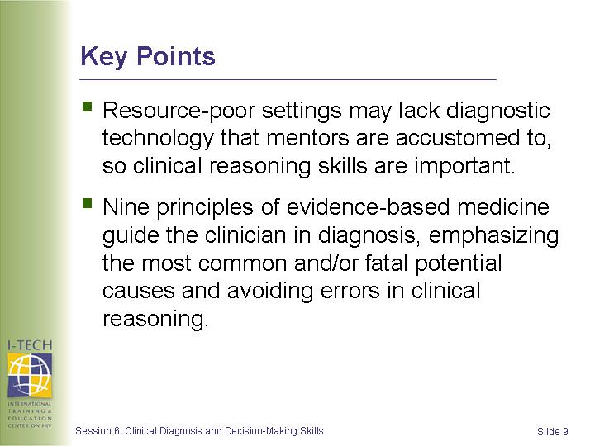 | Review the key points and ask participants if they have any remaining questions.  Present the case study in the following slides

Trainer instructions: Step 4 (slides 10–17)—35 minutes
Slides 10–14 present a case study with questions for participants. Refer to the slide notes and Worksheet 6.2 to conduct this activity.

Slide 10 | 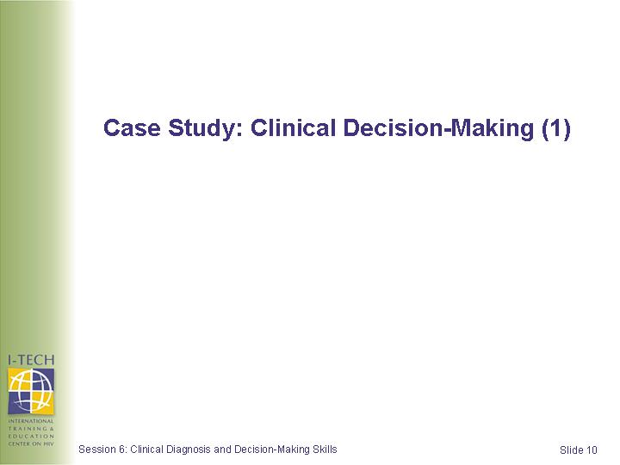 | See Worksheet 6.2 for case study.  - The case is structured to include pauses in the narrative to allow learners to practice clinical decision-making.  - Divide participants into groups of 3-4 and refer them to Worksheet 6.2, which contains the case study and questions.  - Ask participants not to look ahead at the remaining slides in their Participant Handbook while working on this activity. Note that the remaining slides contain the answers to the questions.  - Give the groups 20 minutes to answer questions and then reconvene to review slides 15-17, which contain the answers and relate the case to clinical decision-making principles.
Slide 11 | 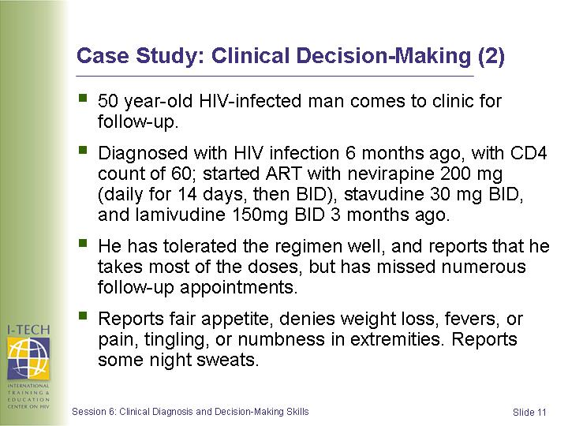
Slide 12 | 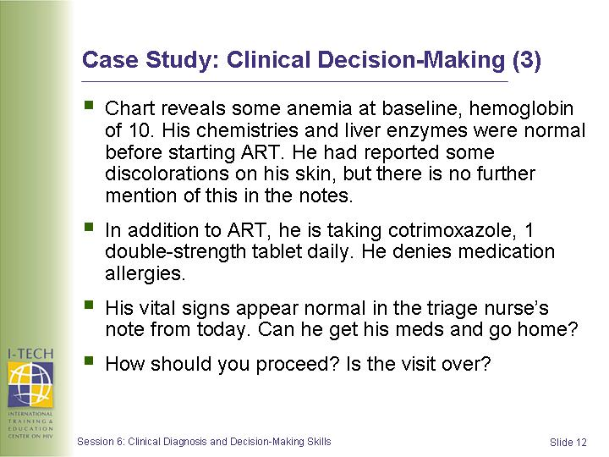
Slide 13 | 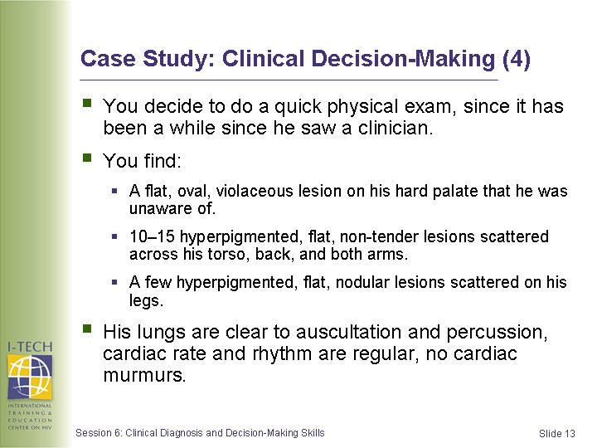
Slide 14 | 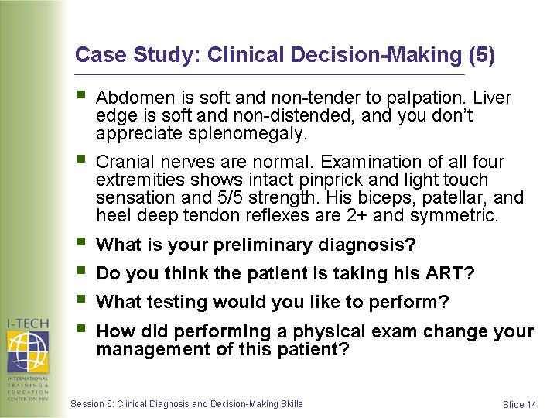

Worksheet 6.2: Clinical Decision-Making Case Study
Case:
50 year-old HIV-infected man comes to clinic for a follow-up visit. He was diagnosed with HIV infection 6 months ago, and had a CD4 count of 60. He started antiretroviral therapy (ART) with nevirapine 200 mg (daily for 14 days, then BID), stavudine 30 mg BID, and lamivudine 150 mg BID 3 months ago. He has tolerated the regimen well, and reports that he takes most of the doses, but has missed numerous follow-up appointments. He reports a fair appetite, denies weight loss, fevers, pain, or tingling or numbness in his extremities. He reports some night sweats. His chart reveals some anemia at baseline (hemoglobin of 10). His chemistries and liver enzymes were normal before starting ART. He had reported some discoloration on his skin, but there is no further mention of this in the notes. In addition to ART, he is taking cotrimoxazole, 1 double-strength tablet daily. He denies medication allergies. His vital signs appear normal in the triage nurse’s note from today. Can he get his meds and go home?
Question:
- How should you proceed? Is the visit over?
- Perform a physical exam because the patient has not seen a clinician in awhile.
Case (continued):
You decide to do a quick physical exam, since it has been a while since he saw a clinician. You find a flat, oval, violaceous lesion on his hard palate that he was unaware of; 10–15 hyperpigmented, flat, non-tender lesions scattered across his torso, back, and both arms; a few hyperpigmented, flat, nodular lesions scattered on his legs. His lungs are clear to auscultation and percussion, and his cardiac rate and rhythm are regular with no cardiac murmurs. His abdomen is soft and non-tender to palpation. His liver edge is soft and non-distended, and you don’t notice any signs of splenomegaly. Cranial nerves are normal. Examination of all four extremities shows intact pinprick and light touch sensation and 5/5 strength. His biceps, patellar, and heel deep tendon reflexes are 2+ and symmetric.
Questions:
- What is your preliminary diagnosis?
- Kaposi sarcoma (KS), in addition to AIDS. It is likely that the patient had KS at the time ART was started because he complained of similar lesions at the time. These may have been misdiagnosed at the time, or the patient may not have been thoroughly examined.
- Do you think the patient is taking his antiretroviral medications (ARVs)?
- The ARVs he is picking up every month may not be getting into his system, either because of poor adherence or he is not absorbing them from his GI tract. He may need chemotherapy in addition to ART to control his disease.

- What testing would you like to perform?
- Obtain a CD4 count to see if he is experiencing immunologic recovery on ART; inquire about his adherence; inquire about symptoms of malabsorption; and obtain a chest x-ray to look for signs of pulmonary KS (usually a nodular infiltrate).
- How did performing a physical exam change your management of this patient?
- KS would have been missed had the examiner trusted the chart and the patient’s self-report, and not performed an independent physical exam.

Slide 15 | 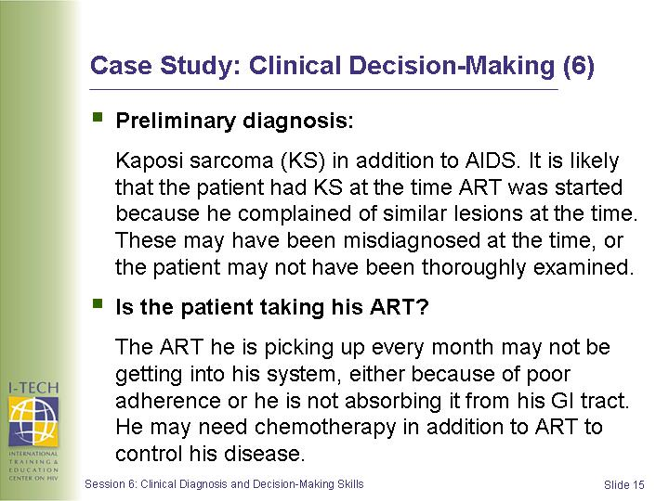
Slide 16 | 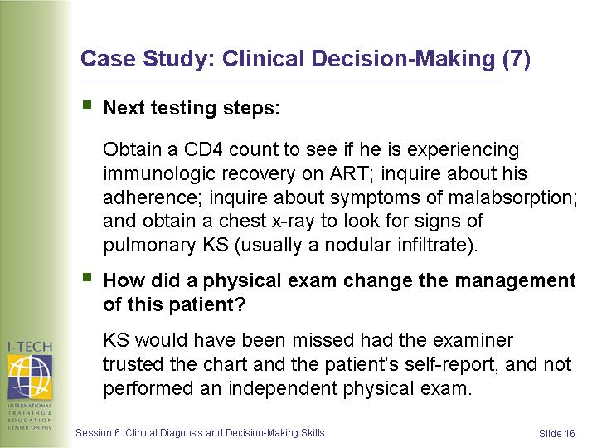
Slide 17 | 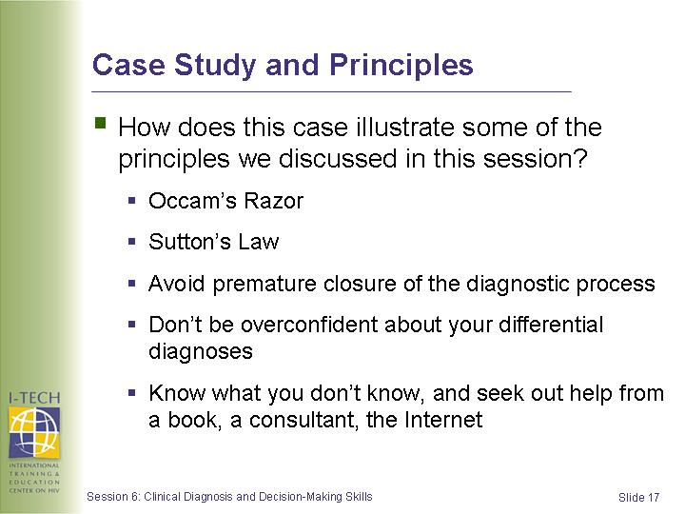 | Summarize the activity and this session.

